Always remembered....
Never forgotten.

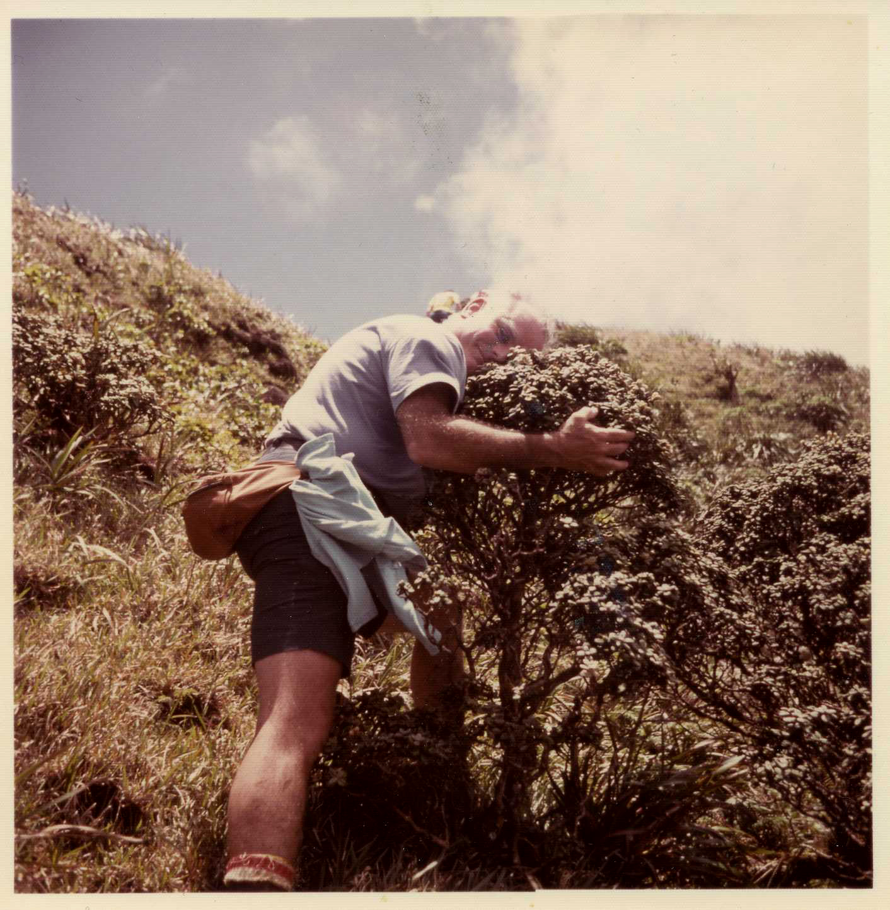
`Ohia Papa

One of Lorin's favorite photos June 1976

Dianne, Mike, and Ed Kiel

